**TUGAS UTS WEB SERVICE**

**Laporan tugas ini di susun guna memenuhi**

**Tugas Ujian Tengah Semester (UTS) Matakuliah Web Service**

**Dosen Pengampu : Wahyu Widodo, S.Kom., M.Kom**



**Disusun Oleh :**

**Nama : Ismail**

**NIM : 12191712**

**Jurusan : Teknik Informatika-Malam**

**SEKOLAH TINGGI MANAJEMEN INFORMATIKA DAN KOMPUTER EL RAHMA YOGYAKARTA**

**2020**

**Database Web Service :**

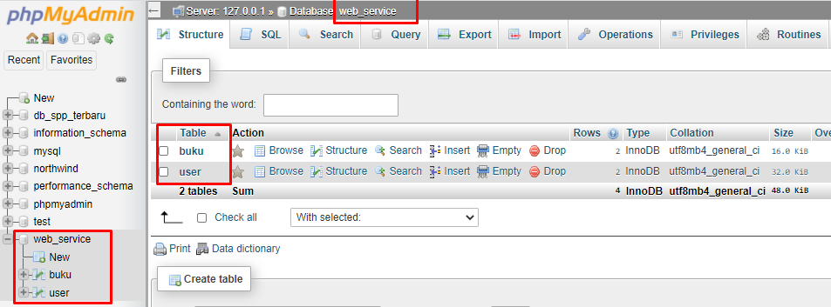

**Tabel Buku :**

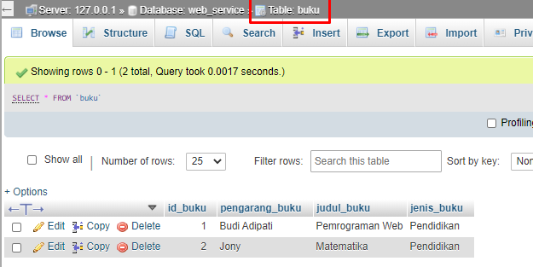

**Tabel User :**

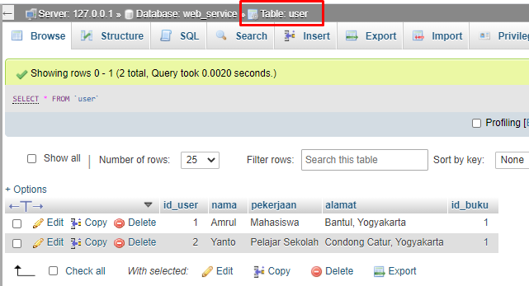

**Relasi Tabel :**

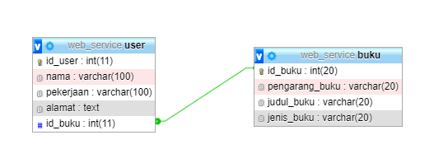

**Ket : User hanya boleh pinjam 1 buku**

**Many to One**

**Script Method Get :**

<?php

defined('BASEPATH') OR exit('No direct script access allowed');

require APPPATH . '/libraries/REST_Controller.php';

use Restserver\Libraries\REST_Controller;

class Buku extends REST_Controller

{

function __construct($config = 'rest')

{

parent::__construct($config);

}

//Menampilkan data Method Get

public function index_get()

{

$id = $this->get('id');

$buku=[];

if ($id == '')

{

$data = $this->db->get('buku')->result();

foreach ($data as $row => $key):

$buku[] = ["id_buku"=>$key->id_buku,

"pengarang_buku"=>$key->pengarang_buku,

"judul_buku"=>$key->judul_buku,

"jenis_buku"=>$key->jenis_buku,

"_links"=>[(object) ["href"=>"user/{$key->id_buku}",

"rel"=>"user",

"type"=>"GET"]],

];

endforeach;

}

else

{

$this->db->where('id_buku', $id);

$data = $this->db->get('buku')->result();

}

$result = ["took"=>$_SERVER["REQUEST_TIME_FLOAT"],

"code"=>200,

"message"=>"Response succesfully",

"data"=>$buku];

$this->response($result, 200);

}

}

?>

**Screnshoot :**

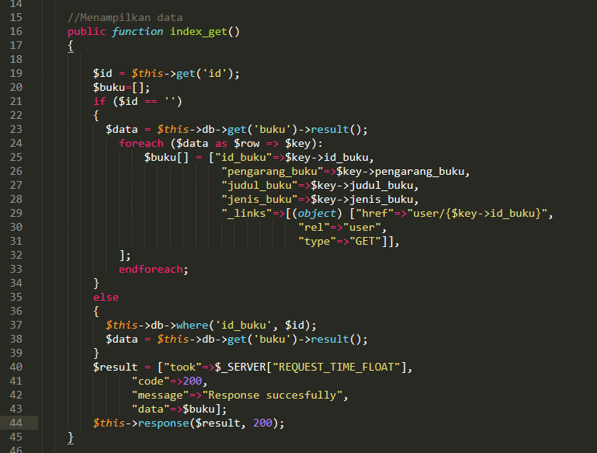

**Hasilnya :**

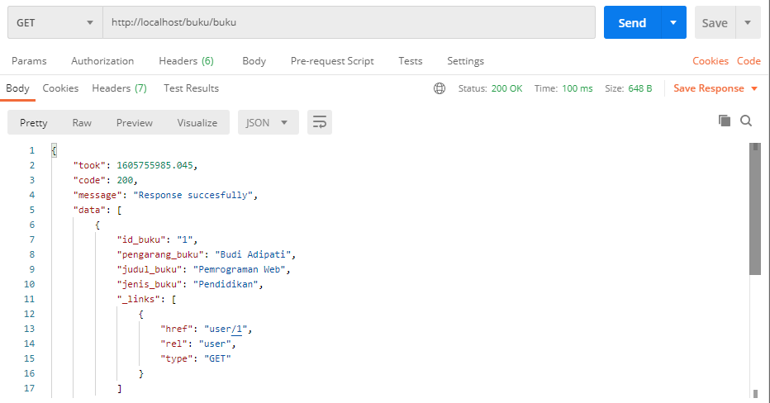

**Hasil Postman dari Method Get :**

{

    "took": 1605757483.313,

    "code": 200,

    "message": "Response succesfully",

    "data": [

        {

            "id_buku": "1",

            "pengarang_buku": "Budi Adipati",

            "judul_buku": "Pemrograman Web",

            "jenis_buku": "Pendidikan",

            "_links": [

                {

                    "href": "user/1",

                    "rel": "user",

                    "type": "GET"

                }

            ]

        },

        {

            "id_buku": "2",

            "pengarang_buku": "Jony",

            "judul_buku": "Matematika",

            "jenis_buku": "Pendidikan",

            "_links": [

                {

                    "href": "user/2",

                    "rel": "user",

                    "type": "GET"

                }

            ]

        }

    ]

}

**Menambah data Method Post :**

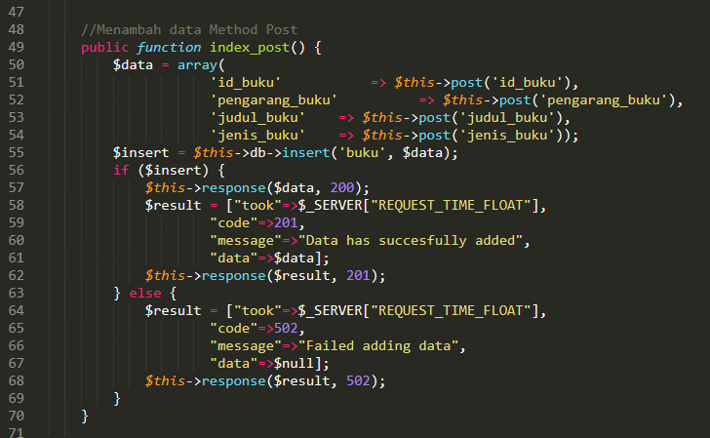

**Hasilnya :**

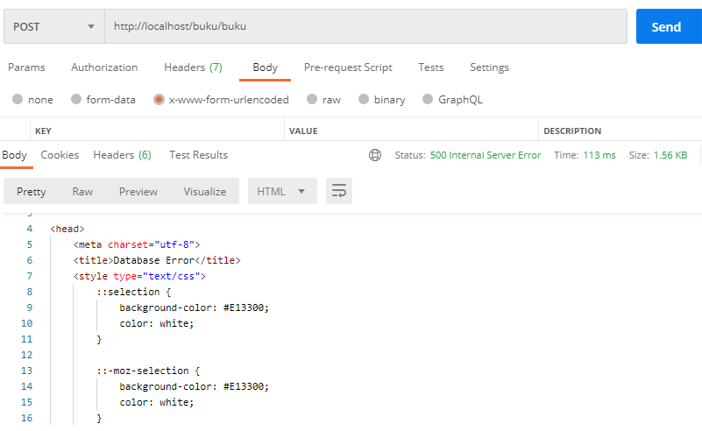

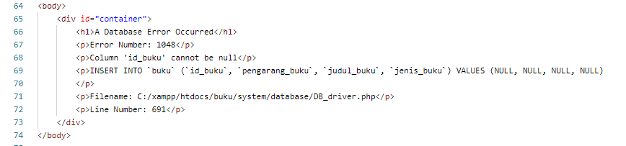

**Karena :**

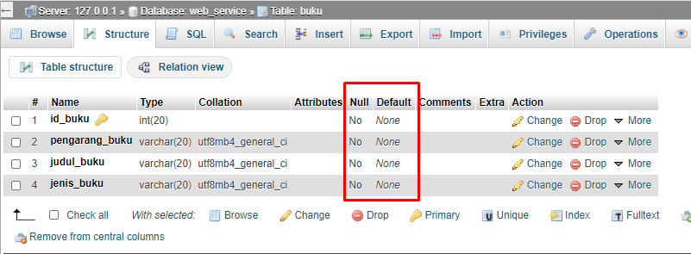

**Keterangan : Bisa error karena defaultnya “None” dan id_buku itu typenya primary key, seharusnya diganti “Null”.**

**Menampilkan data Method Put :**

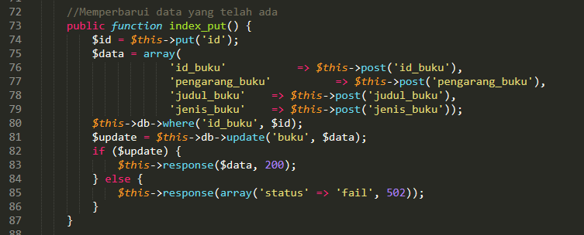

**Hasilnya :**

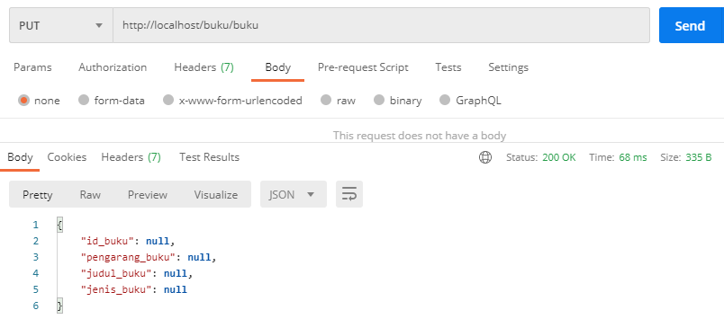

**Menghapus data buku :**

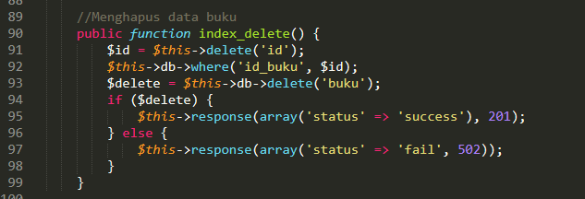

**Hasilnya :**

